XML and XSLT

With XSLT you can transform an XML document into HTML.

Displaying XML with XSLT

XSLT (eXtensible Stylesheet Language Transformations) is the recommended style sheet language for XML.

XSLT is far more sophisticated than CSS. With XSLT you can add/remove elements and attributes to or from the output file. You can also rearrange and sort elements, perform tests and make decisions about which elements to hide and display, and a lot more.

XSLT uses XPath to find information in an XML document.

XSLT Example

We will use the following XML document:

<?xml version="1.0" encoding="UTF-8"?>  
<breakfast_menu>  
  
<food>  
<name>Belgian Waffles</name>  
<price>$5.95</price>  
<description>Two of our famous Belgian Waffles with plenty of real maple syrup</description>  
<calories>650</calories>  
</food>  
  
<food>  
<name>Strawberry Belgian Waffles</name>  
<price>$7.95</price>  
<description>Light Belgian waffles covered with strawberries and whipped cream</description>  
<calories>900</calories>  
</food>  
  
<food>  
<name>Berry-Berry Belgian Waffles</name>  
<price>$8.95</price>  
<description>Light Belgian waffles covered with an assortment of fresh berries and whipped cream</description>  
<calories>900</calories>  
</food>  
  
<food>  
<name>French Toast</name>  
<price>$4.50</price>  
<description>Thick slices made from our homemade sourdough bread</description>  
<calories>600</calories>  
</food>  
  
<food>  
<name>Homestyle Breakfast</name>  
<price>$6.95</price>  
<description>Two eggs, bacon or sausage, toast, and our ever-popular hash browns</description>  
<calories>950</calories>  
</food>  
  
</breakfast_menu>

Use XSLT to transform XML into HTML, before it is displayed in a browser:

Example XSLT Stylesheet:

<?xml version="1.0" encoding="UTF-8"?>  
<html xsl:version="1.0" xmlns:xsl="http://www.w3.org/1999/XSL/Transform">  
<body style="font-family:Arial;font-size:12pt;background-color:#EEEEEE">  
<xsl:for-each select="breakfast_menu/food">  
  <div style="background-color:teal;color:white;padding:4px">  
    <span style="font-weight:bold"><xsl:value-of select="name"/> - </span>  
    <xsl:value-of select="price"/>  
    </div>  
  <div style="margin-left:20px;margin-bottom:1em;font-size:10pt">  
    <p>  
    <xsl:value-of select="description"/>  
    <span style="font-style:italic"> (<xsl:value-of select="calories"/> calories per serving)</span>  
    </p>  
  </div>  
</xsl:for-each>  
</body>  
</html>

[Transform the XML Document with XSLT »](https://www.w3schools.com/xml/simplexsl.xml)

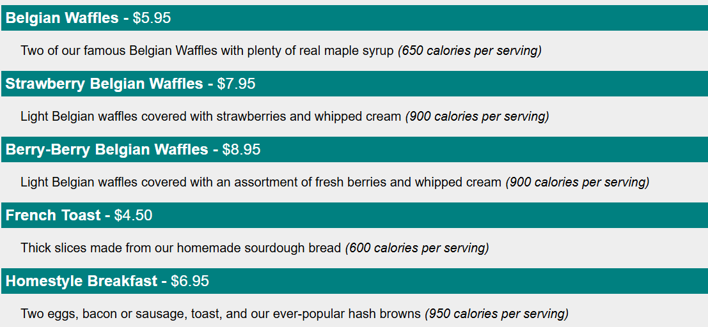

XML and XQuery

What is XQuery?

XQuery is to XML what SQL is to databases.

XQuery was designed to query XML data.

XQuery Example

for $x in doc("books.xml")/bookstore/book  
where $x/price>30  
order by $x/title  
return $x/title

What is XQuery?

|  |  |
| --- | --- |
| XQuery | * XQuery is ***the*** language for querying XML data * XQuery for XML is like SQL for databases * XQuery is built on XPath expressions * XQuery is supported by all major databases * XQuery is a W3C Recommendation |

XQuery is About Querying XML

XQuery is a language for finding and extracting elements and attributes from XML documents.

Here is an example of what XQuery could solve:

"Select all CD records with a price less than $10 from the CD collection stored in cd_catalog.xml"

XQuery and XPath

XQuery 1.0 and XPath 2.0 share the same data model and support the same functions and operators. If you have already studied XPath you will have no problems with understanding XQuery.

XQuery - Examples of Use

XQuery can be used to:

* Extract information to use in a Web Service
* Generate summary reports
* Transform XML data to XHTML
* Search Web documents for relevant information

XQuery is a W3C Recommendation

XQuery is compatible with several W3C standards, such as XML, Namespaces, XSLT, XPath, and XML Schema.

XQuery 1.0 became a W3C Recommendation in 2007.

XML and XPath

What is XPath?

XPath is a major element in the XSLT standard.

XPath can be used to navigate through elements and attributes in an XML document.

|  |  |
| --- | --- |
| XPath | * XPath is a syntax for defining parts of an XML document * XPath uses path expressions to navigate in XML documents * XPath contains a library of standard functions * XPath is a major element in XSLT and in XQuery * XPath is a W3C recommendation |

XPath Path Expressions

XPath uses path expressions to select nodes or node-sets in an XML document. These path expressions look very much like the expressions you see when you work with a traditional computer file system.

XPath expressions can be used in JavaScript, Java, XML Schema, PHP, Python, C and C++, and lots of other languages.

XPath is Used in XSLT

XPath is a major element in the XSLT standard.

With XPath knowledge you will be able to take great advantage of XSL.

ADVERTISEMENT

XPath Example

We will use the following XML document:

<?xml version="1.0" encoding="UTF-8"?>  
  
<bookstore>  
  
<book category="cooking">  
  <title lang="en">Everyday Italian</title>  
  <author>Giada De Laurentiis</author>  
  <year>2005</year>  
  <price>30.00</price>  
</book>  
  
<book category="children">  
  <title lang="en">Harry Potter</title>  
  <author>J K. Rowling</author>  
  <year>2005</year>  
  <price>29.99</price>  
</book>  
  
<book category="web">  
  <title lang="en">XQuery Kick Start</title>  
  <author>James McGovern</author>  
  <author>Per Bothner</author>  
  <author>Kurt Cagle</author>  
  <author>James Linn</author>  
  <author>Vaidyanathan Nagarajan</author>  
  <year>2003</year>  
  <price>49.99</price>  
</book>  
  
<book category="web">  
  <title lang="en">Learning XML</title>  
  <author>Erik T. Ray</author>  
  <year>2003</year>  
  <price>39.95</price>  
</book>  
  
</bookstore>

In the table below we have listed some XPath expressions and the result of the expressions:

|  |  |
| --- | --- |
| **XPath Expression** | **Result** |
| /bookstore/book[1] | Selects the first book element that is the child of the bookstore element |
| /bookstore/book[last()] | Selects the last book element that is the child of the bookstore element |
| /bookstore/book[last()-1] | Selects the last but one book element that is the child of the bookstore element |
| /bookstore/book[position()<3] | Selects the first two book elements that are children of the bookstore element |
| //title[@lang] | Selects all the title elements that have an attribute named lang |
| //title[@lang='en'] | Selects all the title elements that have a "lang" attribute with a value of "en" |
| /bookstore/book[price>35.00] | Selects all the book elements of the bookstore element that have a price element with a value greater than 35.00 |
| /bookstore/book[price>35.00]/title | Selects all the title elements of the book elements of the bookstore element that have a price element with a value greater than 35.00 |

XML and XQuery

What is XQuery?

XQuery is to XML what SQL is to databases.

XQuery was designed to query XML data.

XQuery Example

for $x in doc("books.xml")/bookstore/book  
where $x/price>30  
order by $x/title  
return $x/title

What is XQuery?

|  |  |
| --- | --- |
| XQuery | * XQuery is ***the*** language for querying XML data * XQuery for XML is like SQL for databases * XQuery is built on XPath expressions * XQuery is supported by all major databases * XQuery is a W3C Recommendation |

XQuery is About Querying XML

XQuery is a language for finding and extracting elements and attributes from XML documents.

Here is an example of what XQuery could solve:

"Select all CD records with a price less than $10 from the CD collection stored in cd_catalog.xml"

XQuery and XPath

XQuery 1.0 and XPath 2.0 share the same data model and support the same functions and operators. If you have already studied XPath you will have no problems with understanding XQuery.

XQuery - Examples of Use

XQuery can be used to:

* Extract information to use in a Web Service
* Generate summary reports
* Transform XML data to XHTML
* Search Web documents for relevant information

XQuery FLWOR Expressions

What is FLWOR?

FLWOR (pronounced "flower") is an acronym for "For, Let, Where, Order by, Return".

* **For** - selects a sequence of nodes
* **Let** - binds a sequence to a variable
* **Where** - filters the nodes
* **Order by** - sorts the nodes
* **Return** - what to return (gets evaluated once for every node)

The XML Example Document

We will use the "books.xml" document in the examples below (same XML file as in the previous chapter).

[View the "books.xml" file in your browser](https://www.w3schools.com/xml/books.xml).

How to Select Nodes From "books.xml" With FLWOR

Look at the following path expression:

doc("books.xml")/bookstore/book[price>30]/title

The expression above will select all the title elements under the book elements that are under the bookstore element that have a price element with a value that is higher than 30.

The following FLWOR expression will select exactly the same as the path expression above:

for $x in doc("books.xml")/bookstore/book  
where $x/price>30  
return $x/title

The result will be:

<title lang="en">XQuery Kick Start</title>  
<title lang="en">Learning XML</title>

With FLWOR you can sort the result:

for $x in doc("books.xml")/bookstore/book  
where $x/price>30  
order by $x/title  
return $x/title

The **for** clause selects all book elements under the bookstore element into a variable called $x.

The **where** clause selects only book elements with a price element with a value greater than 30.

The **order by** clause defines the sort-order. Will be sort by the title element.

The **return** clause specifies what should be returned. Here it returns the title elements.

The result of the XQuery expression above will be:

<title lang="en">Learning XML</title>  
<title lang="en">XQuery Kick Start</title>